Arduino project: ultrasonic sensor HC-SR04
D S Băliban
Tehnical university of Cluj Napoca, faculty of Automatics and Applied Informatics
Group 30312

- Ultrasonic sensor HC-SR04
  - Short description
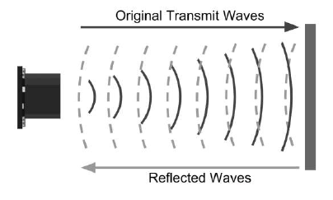

- Ultrasonic sensors are emitting shourt acoustic pulsations, of high frequencies, at regulate time intervals
- They travel through air at the speed of sound
- If they hit an object, they are reflected back as signals to the sensor
- The distance is calculated regardin the time interval between the signal emission and eccho reception
- It will emite a sonic pulse of 40000 Hz in 8 cycles, at pine Trig, which will travel with the speed of sound through air and will be received, after it’s reflexion with an obstacle, at pin Echo
- Echo pin will show the time, in microseconds, that the sound waves made. The duration of the impulse obtained at therminal Echo is between 150 µs and 25 ms

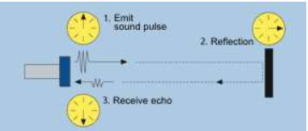

  - Formulas

Distance = speed * time
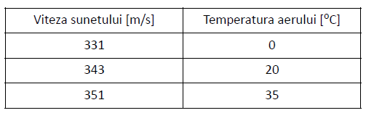
Speed of sound
Air temperature (C)

Speed_{sound}=343 m/s = 0,0343 cm/µs

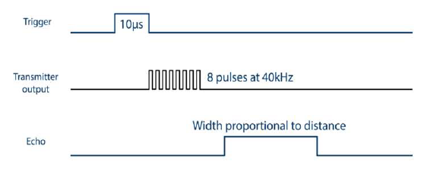
  - Waves

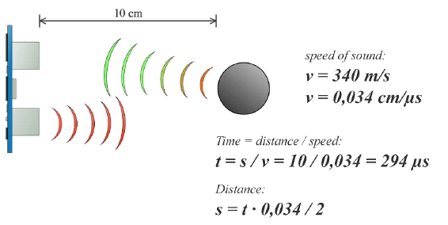

- Connectivity

HC-SR04 Arduino
VCC 5 V
Trig Pin 2
Echo Pin 3
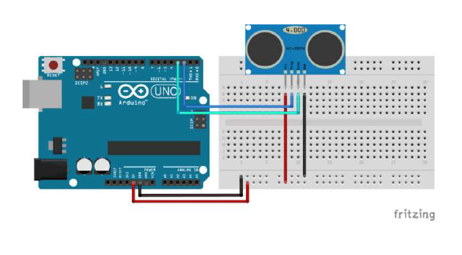
GND GND
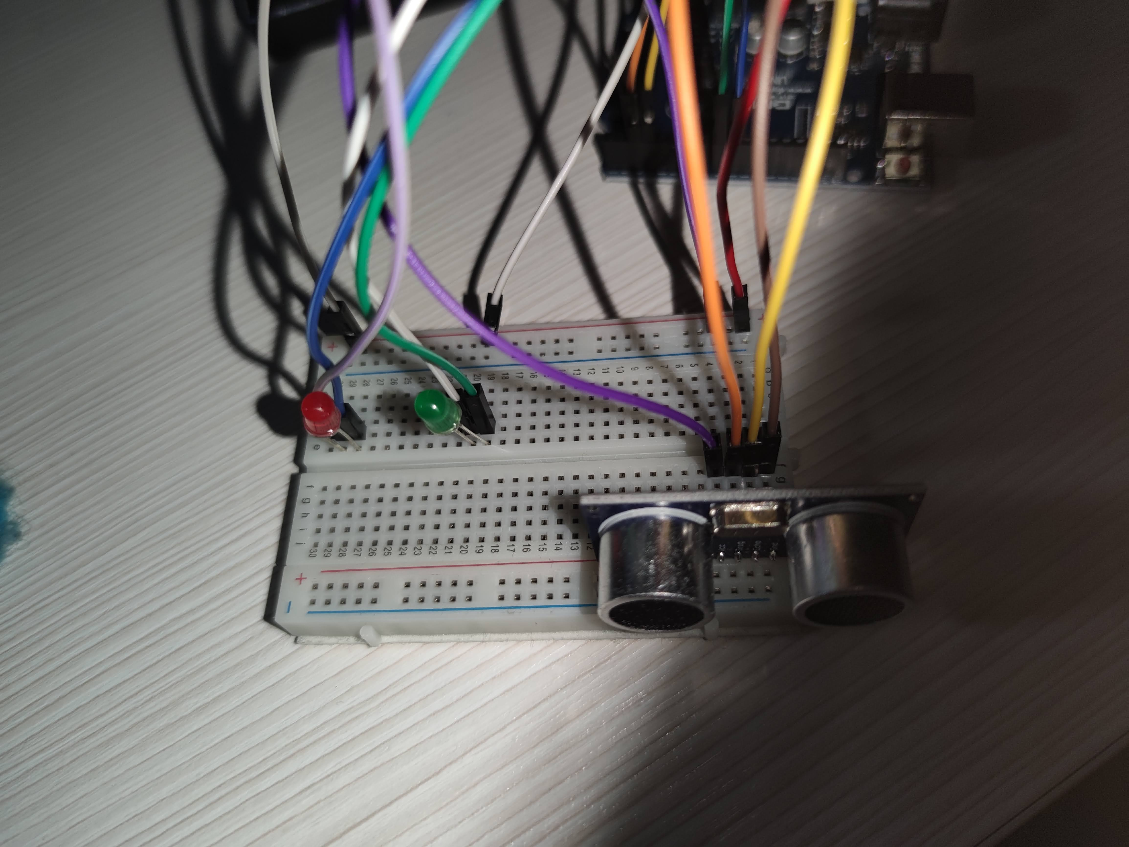

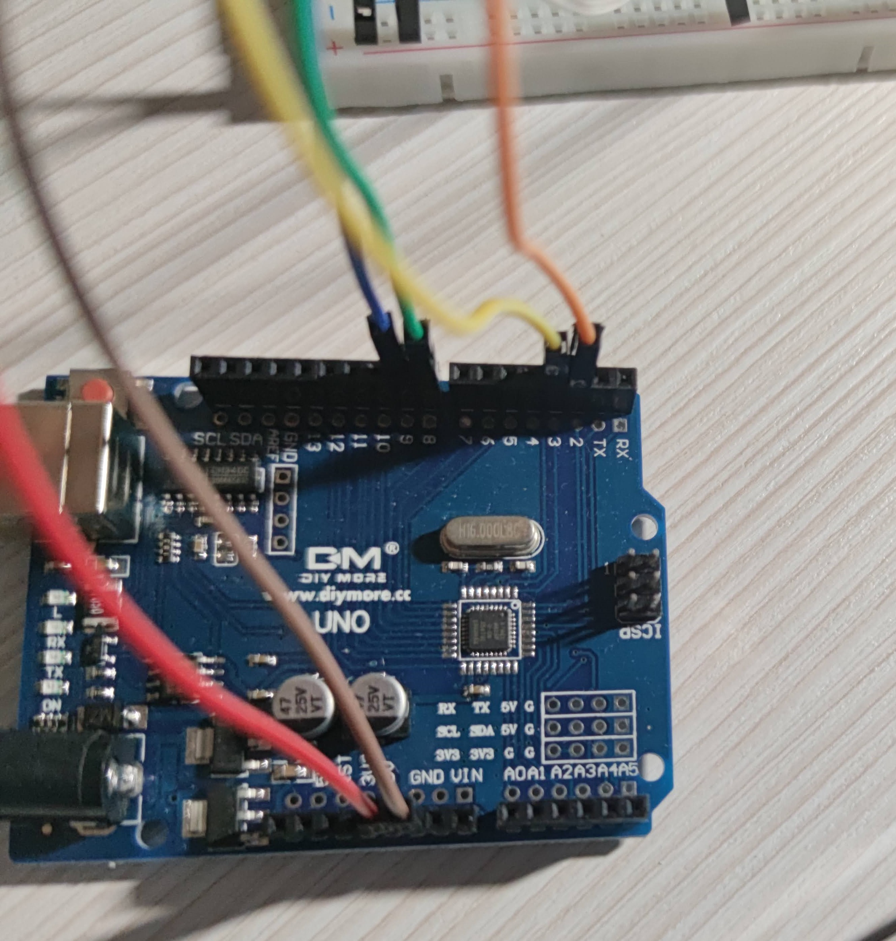

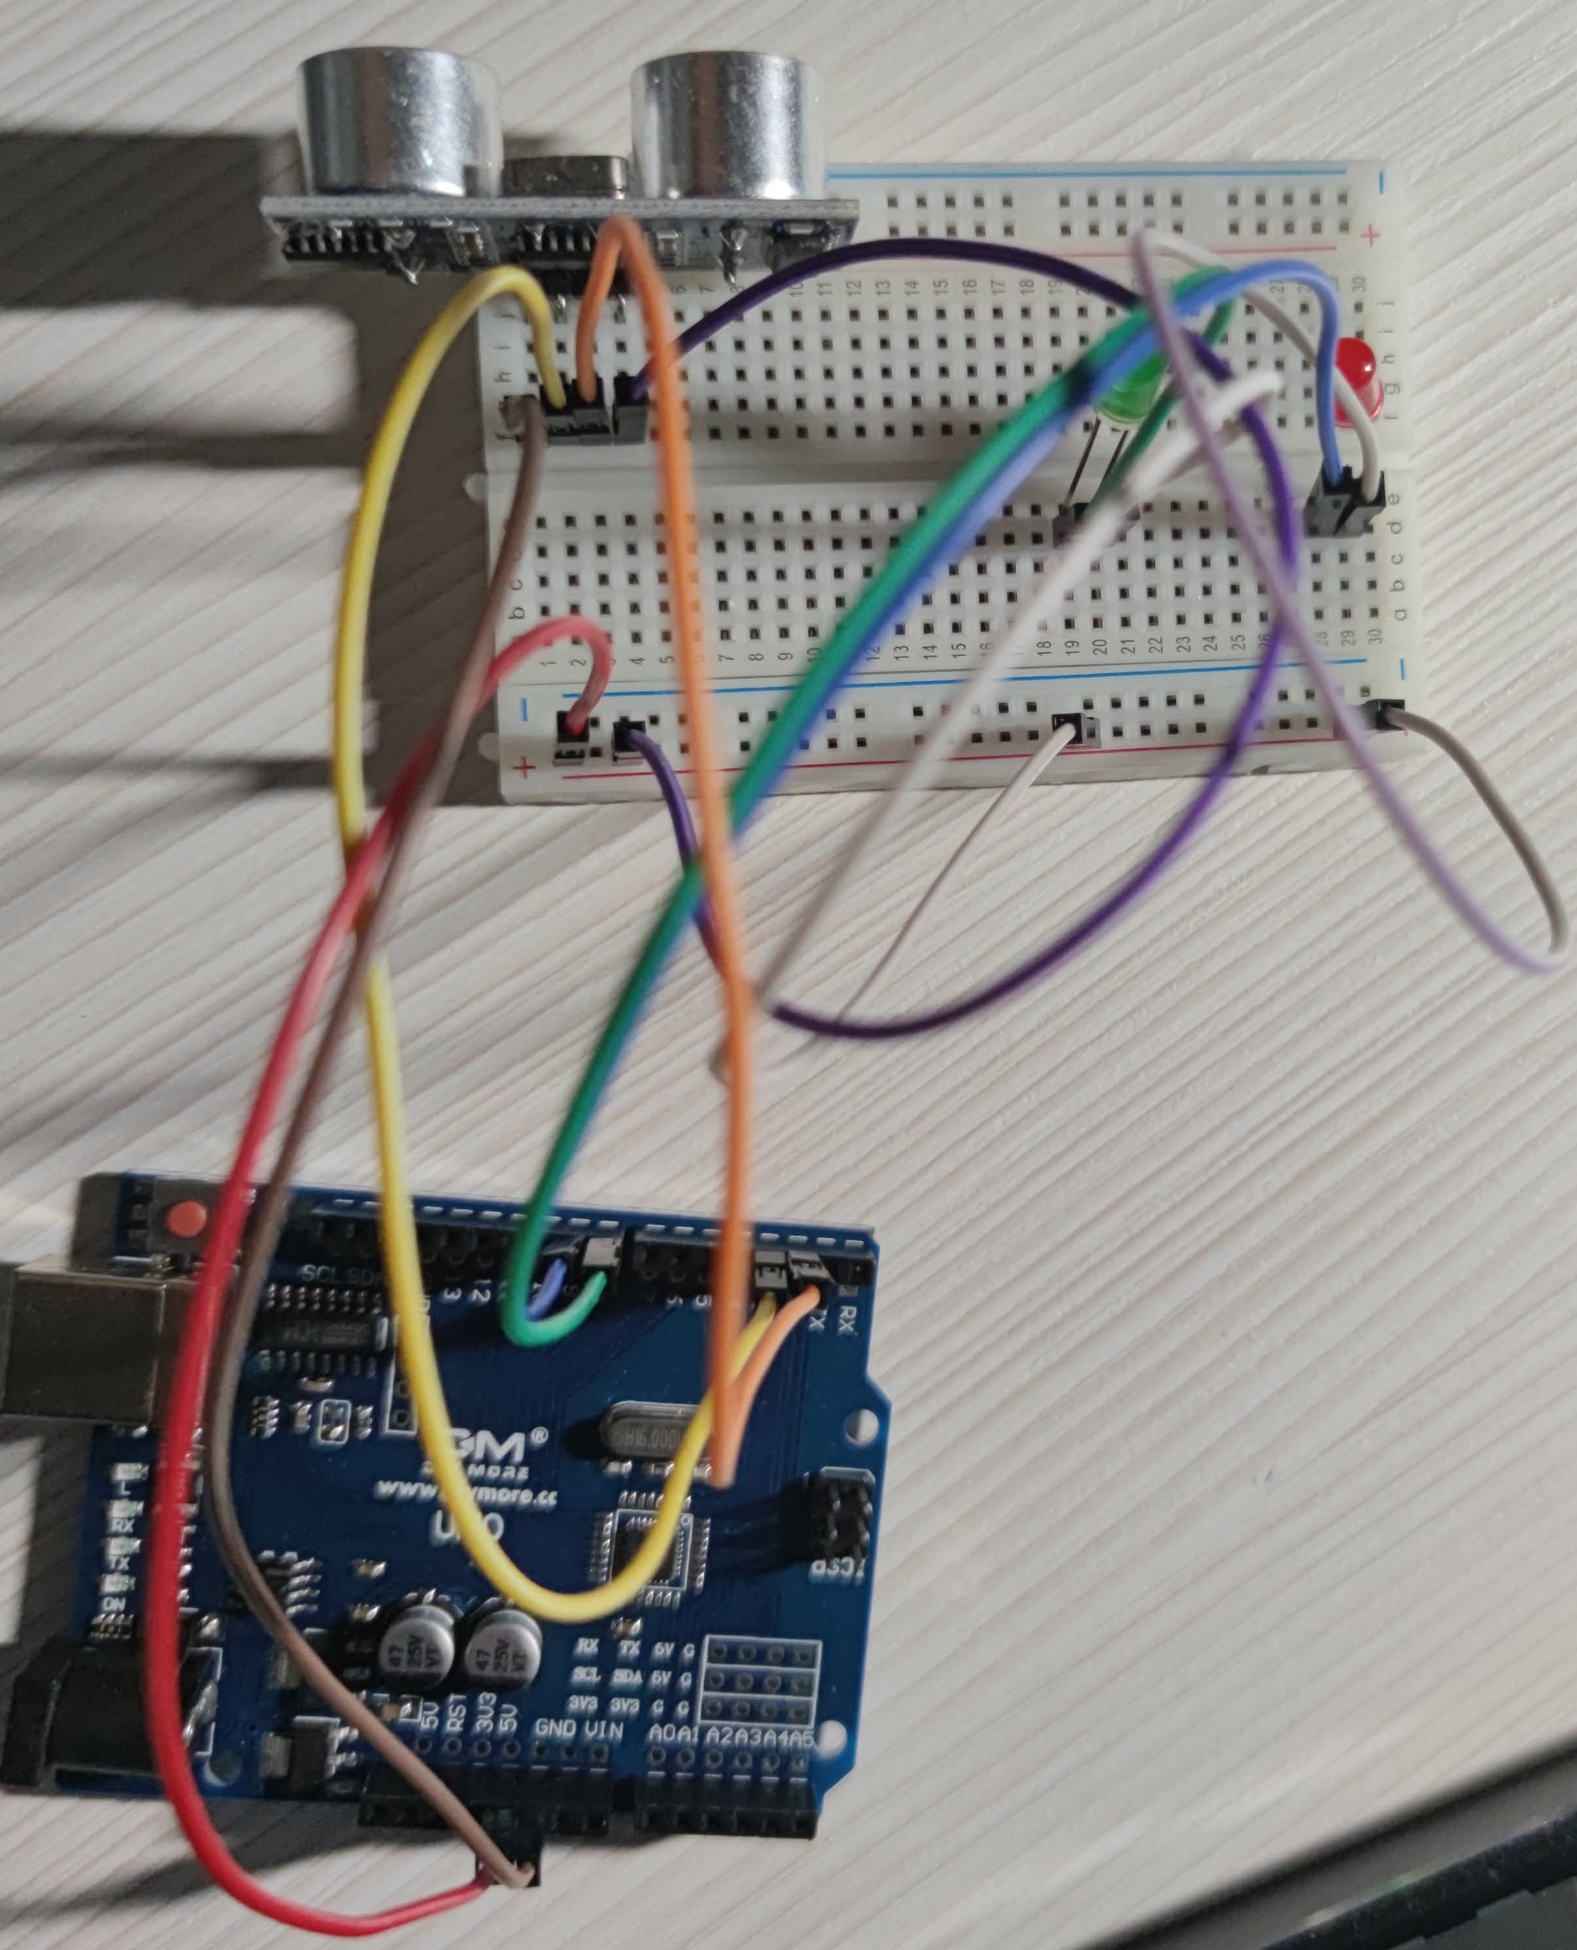

- Project purpose

- The project has the purpose of measuring, in cm, the distance from the ultrasonic sensor to an object. The two LED-s can announce when the object is to close.
- In my example, the green LED will remain on when the distance is greater than 10 cm or lower than 5 cm. Between these two values, the green LED will become on. Of course, these parameters can be changed in the code.

- Code

The module emites a sonic pulse of 8 cycles with 40kHz. For this, pin Trig should pe set at a HIGH level for at least 10 µs after a clean GUGH has been assured by setting pin at LOW level

digitalWrite(trigPin, LOW);
delayMicroseconds(5);
digitalWrite(trigPin, HIGH);
delayMicroseconds(10);
digitalWrite(trigPin, LOW);

The module sets the Echo output signal on 5V and the minicontroler starts the stopwatch for synchronization.
The sound waves are sent and reflected on objects and the first reflection (echo) is considered to be given by the closest object.
The firs eccho received determines the module to set the Echo output signal to 0V.

Duration=pulse(ECHO_PIN, HIGH)

---delayMicroseconds()---

Descripition:
-pauses the program for the amount of time specified by the parameter. There area thousand microseconds in a milisecond.
-the largest value that will produce an accurate delay is 16383. This could change in future arudino releases. For delays longer than a few thousand microseconds, you should use delay() instead

Syntax:
delauMicroseconds(us)

Parameters
us: the nr of microseconds to pause

Returns
nothing
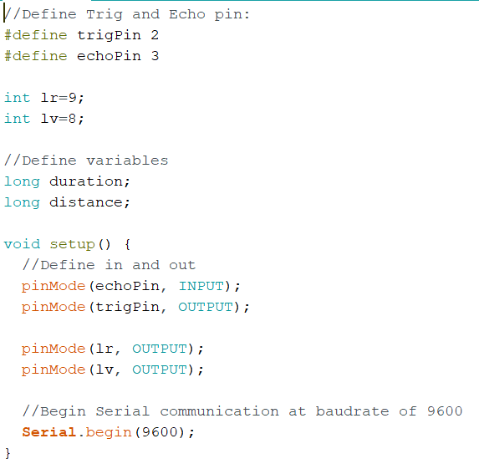

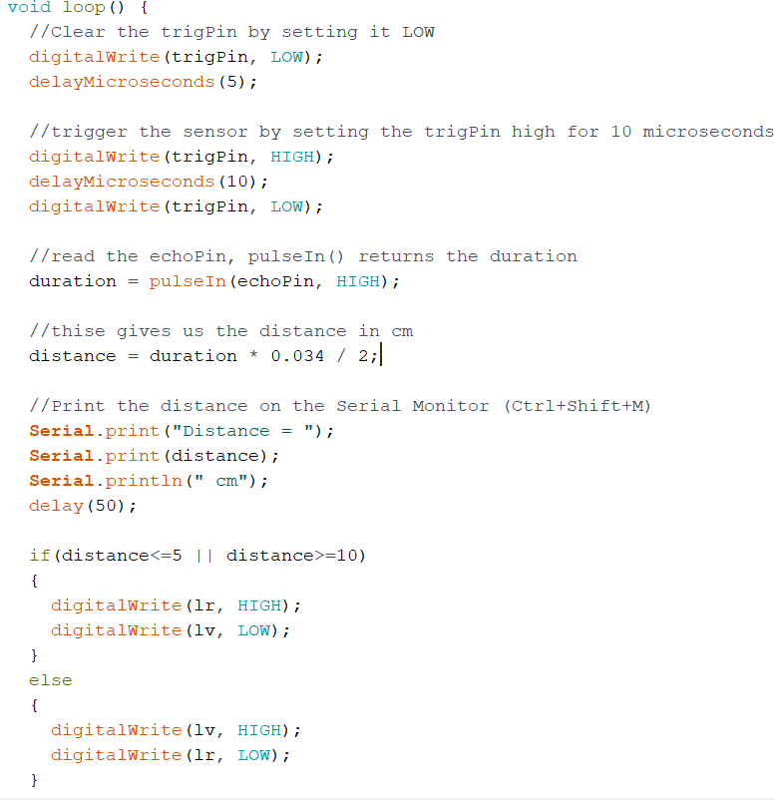

- Conclusions

In conclusion, this project can be associated with a small explanation of how, for example, car parking-sensors actually work, by emitting sound waves which travel through air.
Of course, it can be made in a more advanced way, by adding a display that shows the distance, so that a full size monitor would not be necessary anymore.

- Helpful links

https://www.makerguides.com/hc-sr04-arduino-tutorial/

